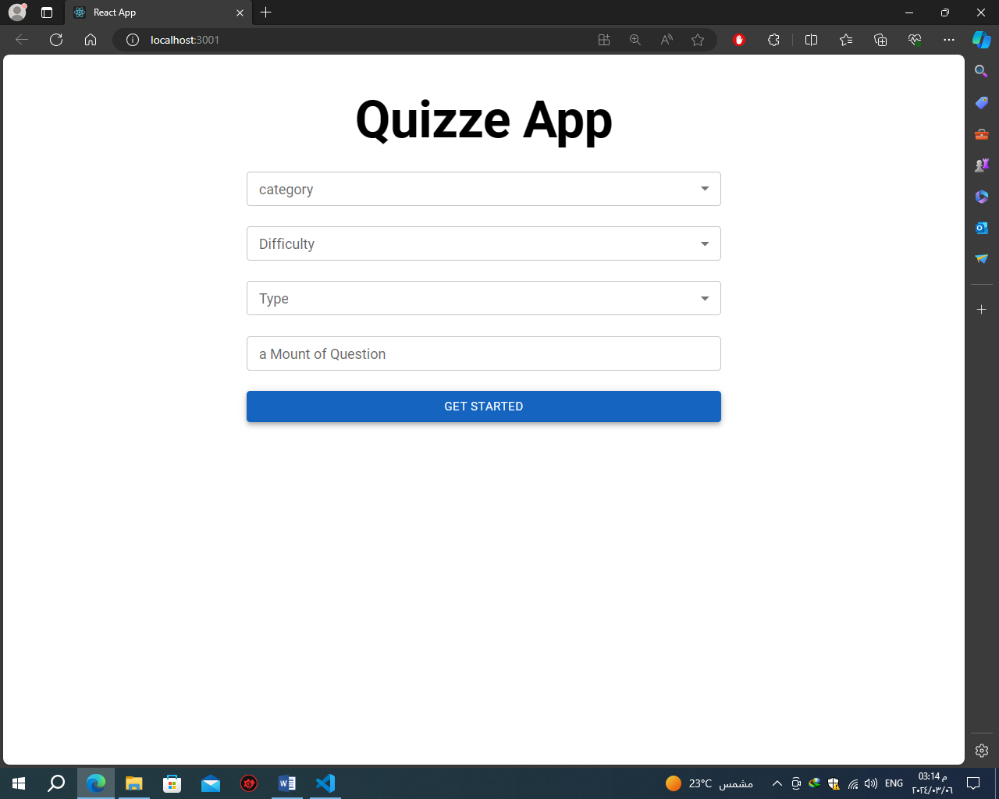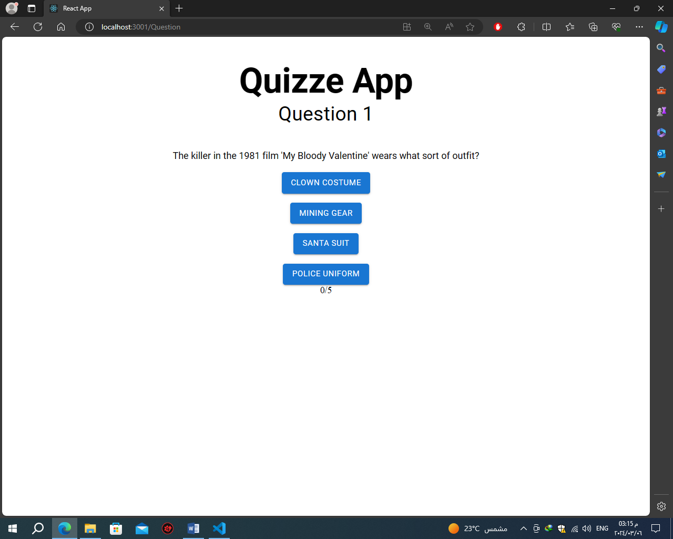**project 1**

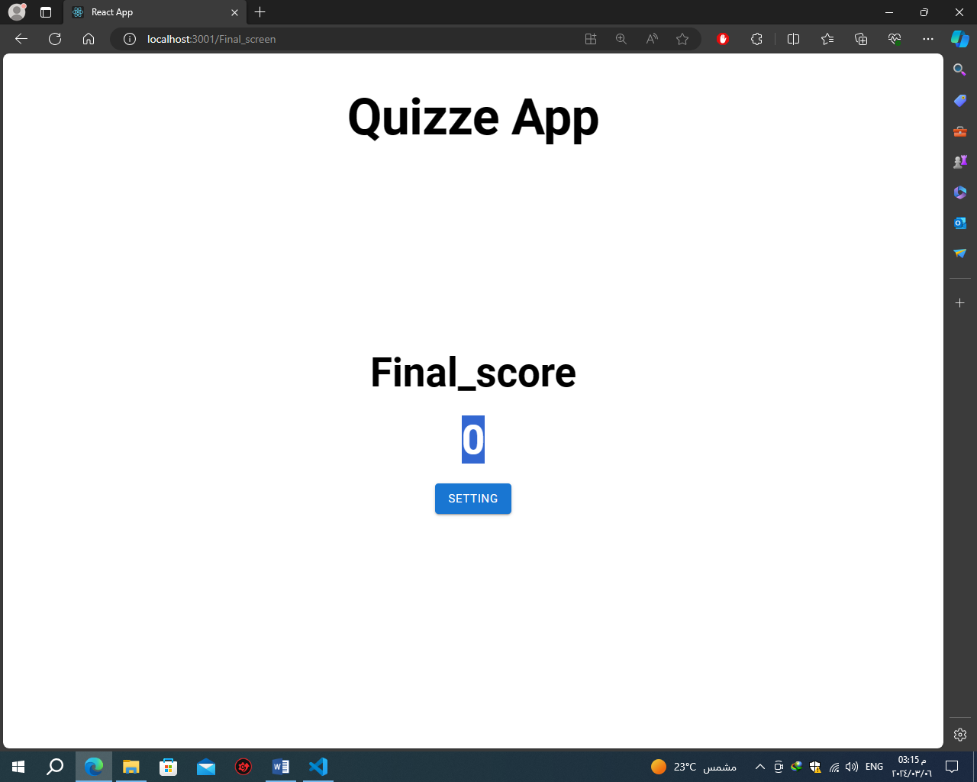

**used :**

* Redux
* Mui (@mui/material)
* React
* Api (/api_category.php)
* Component (SelectFiled-TextFieldComponent)
* Pages (setting-final score-question)
* Hooks(useAxios)

**Problem which I faced**

* Hooks useHistory is not exist so I use useaNagtive
* Hooks switch not exist so I use routes
* e. target. textContent and question. correct_answer variables not have same value which it uses to increase the score so I found the two variables may have extra space so I use (. trim()) to remove it and it work